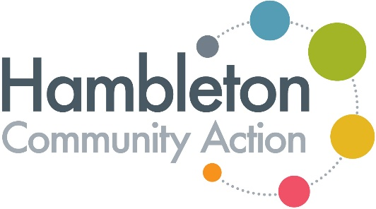
Annual General Meeting
Monday 11th November 2024
Held at Hambleton Community Action, 159/160 High Street, Northallerton

PRESENT:
Michael Harvey, Steve Hadwin, Fiona Ellin, David Walker, Nigel Fox, Caroline Dickinson, Sue Hill, David Simpson, Richard Clark, Kathy Bryan, Ros Day, Liz Lockey, Claire Barnbrook, Erica Partington, Angela Heys, Alison Wragg, Kathryn Watts

APOLOGIES: Joanna Everington, Joan Cundell, Una Ross, Josephine Downes, Jane Whinfrey, Anne Wall, Val Thomas, Maggie Wood, Ann Stafford, Robert Latter, Ruth Barker, Pamela Moffatt, Kathleen Fyles

Item | Discussion | Action
1. | Welcome /Apologies & Minutes of previous years AGM  Michael Harvey, Chair welcomed everyone to the meeting and the apologies (listed above) were noted. The minutes from the previous year’s AGM on 6th November 2023 were reviewed and accepted as a true record of the meeting. There were no matters arising.
2. | Chairs report - Michael Harvey, Chair of Trustees  Michael provided his verbal report and acknowledged the sadness felt by the loss of Lizzie Clapham in November 2023. A celebration of her life was held in UpFront in January 2024. The most significant development in the year was the opening and success of the UpFront community venue. Michael expressed thanks to the volunteers, staff and funders.  There were no questions asked.
3. | New staff introductions – Liz Lockey  During the year several new staff were recruited:  - Giles joined the team as Wheels 2 Work co-ordinator  - Nicola as the ‘By Your Side’ project officer  - Clare as Digital Champion co-ordinator and UpFront assistant  - Kate as the Health Inequalities Project Manager  - Poppy has also most recently joined us as the premises cleaner
4. | Chief Officers Report – Liz Lockey  Liz presented the Impact Report (attached) which provided details of services during the year and talked about the new initiatives this year.  Liz gave thanks to all the volunteers, trustees and staff involved.
5. | Treasurers report / presentation of accounts and Election of Independent Examiner  David Walker presented a summary of the accounts.  At 31 March 2024 HCA had total assets of £217,101, down from £303,548 resulting in an operational deficit of £86447.00 for the period. £61500.00 of this was planned expenditure charged to the designated fund which is the legacy of the late trustee June Darrah being drawn down over a period of three years.  David confirmed that the the policy on reserves has been met by ensuring there are 6 months funding in our accounts.  David thanked Erica and Sandra who do the day-to-day running of the accounts and thanked all the staff.  David proposed T P Jones as the Independant Examiner of Accounts once again.  This proposal was seconded by Liz Lockey and agreed by a show of hands from the members present.  The accounts were approved.
6. | Election of Trustees  Michael Harvey & Andy Powell retired from office by rotation. Andy Powell stood down and Michael stood for re-election. Michael was re-elected to the board of trustees, proposed by David, seconded by Fiona and by a show of hands from members at the meeting. All other trustees agreed to remain in post.
7. | Election of Officers  The Chair proposed that the officer positions were deferred to the next committee meeting. This was seconded by Fiona and agreed by the members present.
8. | Any other business  Flowers were presented to Alison Wragg for her birthday.  A discussion took place around the good support provided for refugees in the Northallerton area.

